**DOCUMENTATION**

**SUBMITTED BY:**-

Name: Ayushi Choudhary (Team Head)

Registration ID: SIRSS2316

College: Maharaja Surajamal Institute Of Technology, (Affiliated to GGSIPU,Delhi)

Name: Shivam Jha (Team Vice Head)

Registration ID: SIRSS2317

College: Maharaja Surajamal Institute Of Technology, (Affiliated to GGSIPU,Delhi)

Name: Aftab Ahmed

Registration ID: SIRSS2310

College: College of Engineering and Technology, Bhubaneswar

Team effort together with precious words of encouragement and guidance makes daunting tasks achievable. It is a pleasure to acknowledge the direct and implied help I have received at various stages in the task of completing the project. I find it impossible to express my thanks to each one of them in words, for it seems too trivial when compare to the profound encouragement that they extended to us.

I hereby perceive this opportunity as a big milestone in my career development. I will use gained skills and knowledge in the best possible way and continue to work on their improvement.

**ABSTRACT**

Every company will say they are doing a form of data science, but what exactly does that mean? The field is growing so rapidly, and revolutionizing so many industries, it's difficult to fence in its capabilities with a formal definition, but generally data science is devoted to the extraction of clean information from raw data for the formulation of actionable insights.

**Machine learning** is the study of computer algorithms that improve automatically through experience. It focuses on the development of computer programs that can access data and use it learn for themselves. Because of this, it facilitates computers in building models from sample data in order to automate decision-making processes based on data inputs. In this project, we experimented with real world data set and explored how machine learning algorithm can be used to find patterns in data. We were expected to gain experiences using common data cleaning, machine learning libraries and were expected to submit a documentation about the data set and algorithm used. After performing the required task on data set up my choice here in lies my final document.

**Project** is based on applications in the stock price prediction. In this machine learning project, we will be talking about predicting the returns on stocks. We will analyse daily stocks status and predict for the next day

**Data Science with Python**

**Data science** is an inter-disciplinary field that uses scientific methods, processes, algorithms and systems to extract knowledge and insights from many structural and unstructured data. It is a "concept to unify statistics, data analysis and their related methods" in order to "understand and analyze actual phenomena" with data. It is related to data mining, machine learning and big data.

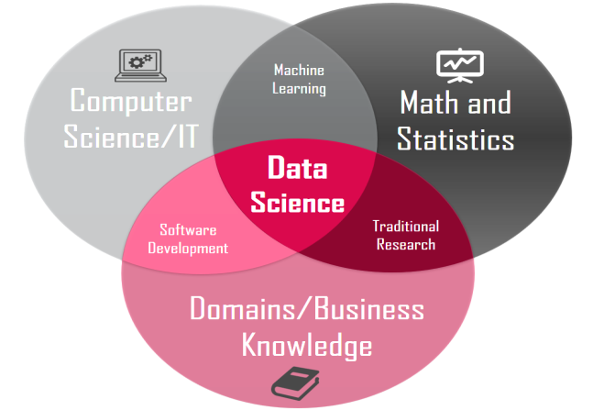

**Python** is open source, interpreted, high level language and provides great approach for object-oriented programming. It is one of the best language used by data scientist for various data science projects/application. It provide great functionality to deal with mathematics, statistics and scientific function. It is a programming language with simple syntax that is commonly used for data science. There are a number of python libraries that are used in data science including Pandas, SciPy etc…



**Python Fundamentals:**-

The basic Python curriculum can be broken down into 4 essential topics that include:

* **Data Types(Int, Float, Strings& Boolean) :**

Data types are the classification or categorization of data items. Data types represent a kind of value which determines what operations can be performed on that data. Numeric, non-numeric and Boolean (true/false) data are the most used data types.

**Integer:** Positive or negative whole numbers (without a fractional part)

**Float:** Any real number with a floating point representation in which a fractional component is denoted by a decimal symbol or scientific notation.

**String:** A string value is a collection of one or more characters put in single, double or triple quotes.

**Boolean:** Data with one of two built-in values True or False. Notice that 'T' and 'F' are capital. true and false are not valid Booleans and Python will throw an error for them.

* **Compound data structures(Lists, Tuples, Sets and Dictionaries) :**

A compound data type in which the values are made up of components, or elements, that are themselves values. default value.

**List :** A list object is an ordered collection of one or more data items, not necessarily of the same type, put in square brackets. It can have similar values in the same list.

Ex:myset = [10, 20, 30,20,30,”hello”]

**Tuple:** A Tuple object is an ordered collection of one or more data items, not necessarily of the same type, put in parentheses.

Ex:mytuple = (10, 20, 30,”hello”)

**Set :** It is a collection which is unordered and unindexed. In Python, sets are written with curly brackets.They also don’t accept to have duplicate values.

Ex:myset = {10, 20, 30,”hello”}

**Dictionary :** It is an unordered collection of data in a key: value pair form. A collection of such pairs is enclosed in curly brackets.

Ex: {1:"Steve", 2:"Bill", "Ram":3.2 , 4: "Farha"}

An **External library** is something that comes from an outside source. These libraries are a set of useful functions that eliminate the need for writing codes from scratch. A Python library is a reusable chunk of code that you may want to include in your programs/ projects. Compared to languages like C++ or C, a Python libraries do not pertain to any specific context in Python. Here, a 'library' loosely describes a collection of core modules.

Python has a huge community providing support for its libraries and keeping them updated.

There are over 137,000 python libraries present today. Python libraries play a vital role in developing machine learning, data science, data visualization, image and data manipulation applications and more.

Ex: NumPy, Pandas, Matplotlib, Seaborn, SciPy etc.

**What is a machine learning algorithm?**

A machine learning algorithm is an algorithm that is able to learn from data. But what do we mean by learning? Mitchell (1997) provides a succinct definition: “A computer program is said to learn from experience E with respect to some class of tasks T and performance measure P, if its performance at tasks in T, as measured by P, improves with experience E.”

**What is Natural Language Processing?**

Natural language processing (NLP) is the use of human languages, such as English or French, by a computer. Computer programs typically read and emit specialized languages designed to allow efficient and unambiguous parsing by simple programs. More naturally occurring languages are often ambiguous and defy formal description. Natural language processing includes applications such as machine translation, in which the learner must read a sentence in one human language and emit an equivalent sentence in another human language. Many NLP applications are based on language models that define a probability distribution over sequences of words, characters, or bytes in a natural language.

**RNN**  
Deep feedforward networks, also called feedforward neural networks, or multilayer perceptrons (MLPs), are the quintessential deep learning models. The goal of a feedforward network is to approximate some function f*. For example, for a classifier, y = f*(x) maps an input x to a category y. A feedforward network defines a mapping y = f(x; **θ**) and learns the value of the parameters **θ** that result in the best function approximation.

**LSTM**

LSTM stands for **Long short term memory**, and they are a type of RNN (**recurrent neural network**) which is well suited for sequence prediction problems. Based on the previous text, we can predict what the next word will be. It has proven itself effective from the traditional RNN by overcoming the limitations of RNN which had short term memory. LSTM can carry out relevant information throughout the processing of inputs and with a forget gate, it discards non-relevant information.

The following image shows what an LSTM cell looks like –

[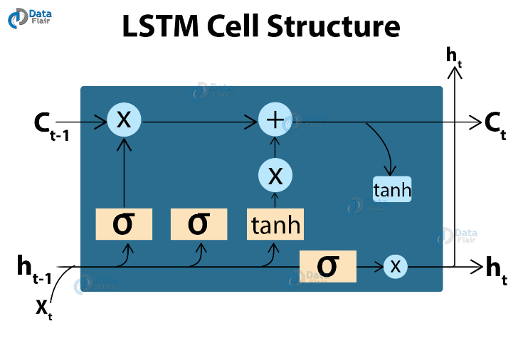](https://data-flair.training/blogs/wp-content/uploads/sites/2/2019/11/LSTM-Cell-Structure-project-in-python.png)

LSTMs are widely used for sequence prediction problems and have proven to be extremely effective. The reason they work so well is that LSTM can store past important information and forget the information that is not.

LSTM has three gates:

* The input gate: The input gate adds information to the cell state,
* The forget gate: It removes the information that is no longer required by the model,
* The output gate: Output Gate at LSTM selects the information to be shown as output

While Implementing any LSTM, we should always reshape our X train in 3-D, add 1 the reason behind is the time step and the 1 is given to the LSTM.

### Stacked LSTMs

Stacked LSTMs are now a stable technique for challenging sequence prediction problems. A Stacked LSTM architecture can be defined as an LSTM model comprised of multiple LSTM layers. An LSTM layer above provides a sequence output rather than a single value output to the LSTM layer below. Specifically, one output per input time step, rather than one output time step for all input time steps.

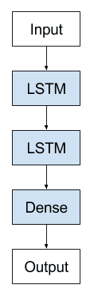

Stacked Long Short-Term Memory Archiecture

### Stock Prediction

Trying to predict how the securities exchange will work is one of the most difficult tasks. There are so many variables involved with the expectation – physical elements versus psychological factors, rational and irrational behaviour, and so on.

All of these factors combine to make share costs unpredictable and difficult to predict with any degree of certainty.

AI approaches will potentially reveal examples and insights we hadn’t seen before, and these can be used to make unerringly exact expectations, using features like the most recent declarations of an organization, their quarterly income figures, and so on.

We will work with published information regarding a freely recorded organization’s stock costs in this report.

We’ll use a combination of AI calculations to forecast this company’s future stock price with LSTM.

**Steps involved in making, training and testing our stock prediction model**

## Loading the Data

1. LSTM is sensitive to the scale of the data, so we apply MinMax scaler
2. Train and Test Split
3. Data Preprocessing
4. Convert an array of values into a dataset matrix and reshaping the input for LSTM
5. Implementation of stacked LSTM
6. Prediction and checking performance metrics(RMSE)
7. Plotting
8. Demonstrating prediction for next 10 days

The following diagram shows the structure of the model that we have made:

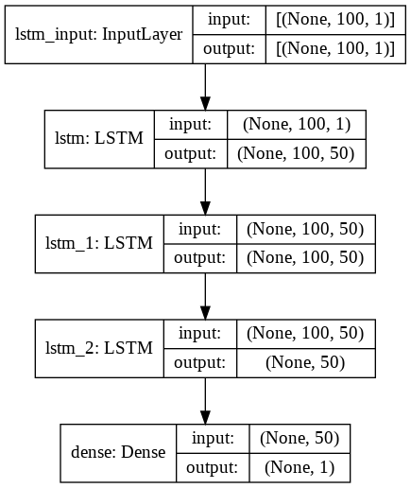

**Output Plots:**

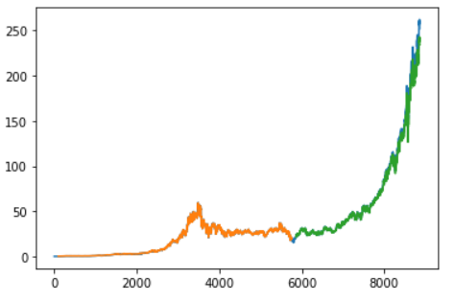

Plot baseline and predictions

